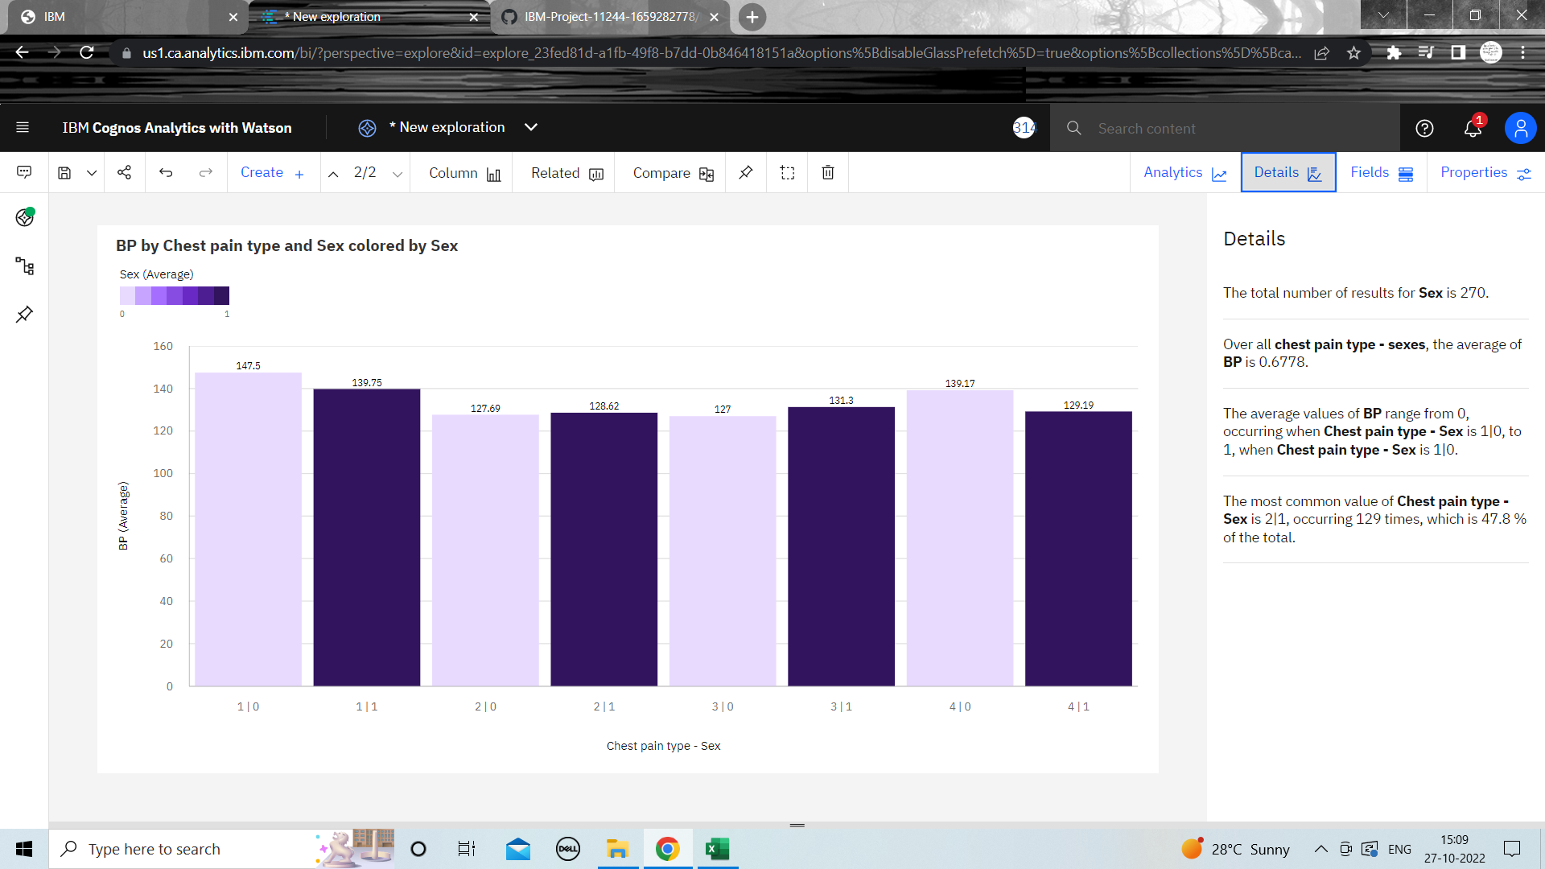**Exploration of BP vs Chest pain type and Gender**